# **Error Detection and Correction**

* Single bit error
* Burst error

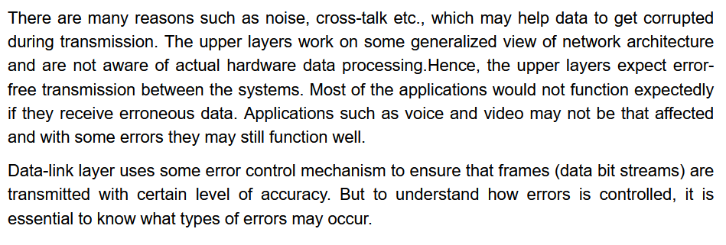



## **Types of error**

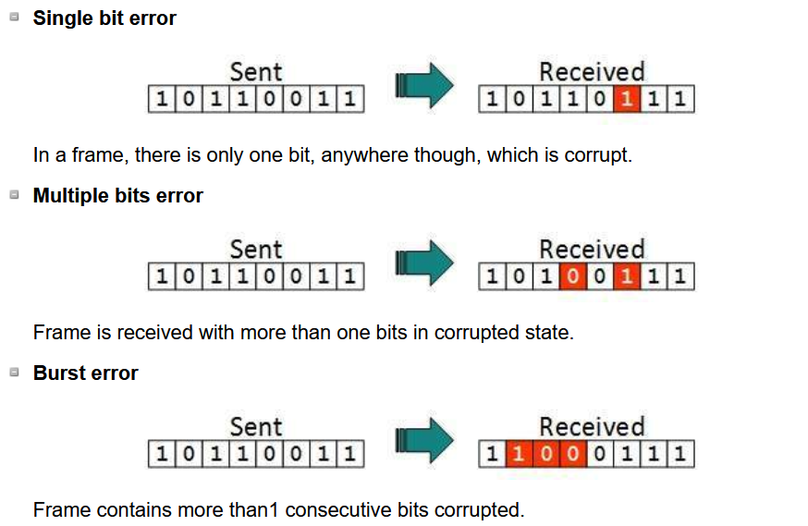  
length of this burst error 🡪 5



***If the bandwidth of a channel is 1 gbps, then how far much duration the error should last ???***

## **Error Detection**

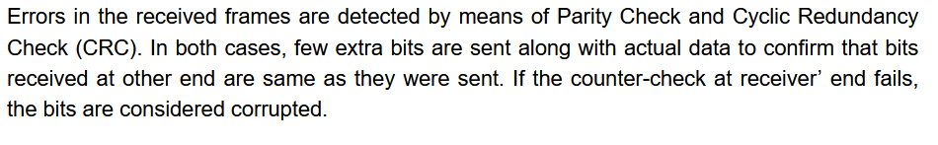

Error detection uses the concept of redundancy, which means adding extra bits for detecting the errors at the destination.

* Single Parity (Odd and even parity)
* 2D Parity check
* Check Sum **(Imps)**
* CRC(Cyclic Redundancy Check) **(Imps)**

## **Correction**

* Hamming Codes

# **Single Bit parity along with Hamming Distance Concept**

* m+1 bits where m is the message bits
* even parity 🡪 even number of ones

i) 10100 ii) 11101  
 data data



* odd parity 🡪 odd number of ones

i) 10101 ii) 11100  
 data data



* Can detect all single bit errors in the code word.  
  sender = 11101  
  receiver = 01101  
  Parity can find some errors are there but can’t able to find the exact place where the error has occurred.



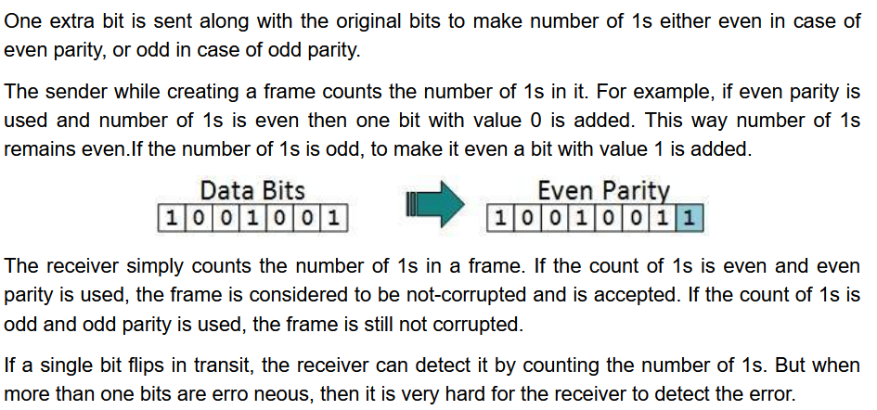

## **Single-dimensional Parity check**

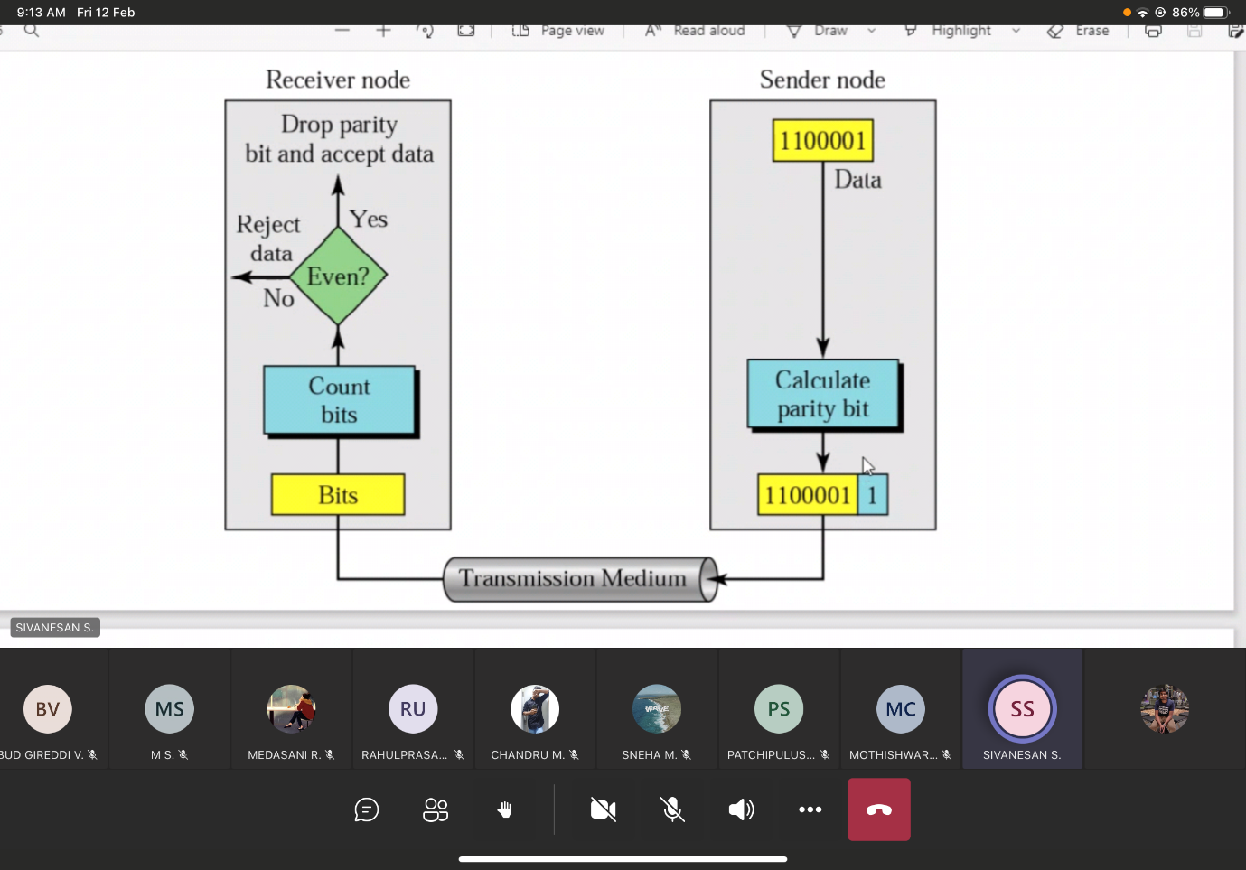

## **Two-dimensional Parity check (Longitudinal Redundancy Check)**

## 



Parity of Parity



Original 🡪 28 bits   
Appended 🡪 40 bits (so transmission cost is high)

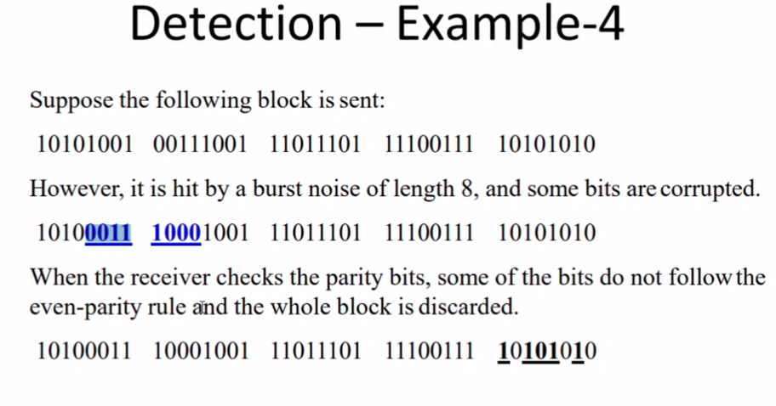

# **Check-Sum**

